Apriori Documentation

To initiate the process, it is essential to prepare the data for analysis employing the Apriori algorithm. Collect the transaction data intended for analysis and ensure its proper structure. Each transaction should be represented as a distinct entry, with the items listed within each transaction. The transaction data can be arranged as lines of text, where each line corresponds to a transaction and contains a comma-separated enumeration of items.

Once the transaction data is properly prepared, proceed to execute the Flask application that deploys the Apriori algorithm. Access your terminal or command prompt, navigate to the project directory that houses the Flask application file, and commence the Flask development server.

Access the Flask application through your preferred web browser. The application interface will present a form featuring input fields. Within the "Transactions" field, input your prepared transaction data, ensuring that each transaction occupies a separate line and that the items within each transaction are separated by commas. In the "Items" field, input a comma-separated list encompassing all potential items within your transactions.

Establish the "Minimum Support" and "Minimum Confidence" values in accordance with the thresholds you wish to apply to the Apriori algorithm. These values ascertain the level of support and confidence required for an association rule to be deemed significant.

Subsequently, submit the form by selecting the "Run Apriori" button. The Flask application will receive the transaction data, item list, minimum support, and minimum confidence values. This data will be passed to the Apriori algorithm function defined in the application.

Within the Apriori algorithm function, implement the logic of the Apriori algorithm to process the data. Parse the transaction data and extract the individual items to conduct association rule mining. Execute the necessary steps of the Apriori algorithm, such as identifying frequent itemsets and generating association rules based on the specified minimum support and minimum confidence thresholds.

Upon completion of the data processing by the Apriori algorithm, the Flask application will obtain the resulting association rules. These rules encapsulate the relationships between different items within the transactions. The application will exhibit the association rules on the same page, positioned beneath the form.

Analyze the association rules to extract insights into the relationships and patterns discovered in the transaction data. These insights facilitate comprehension of the co-occurrence and interdependence among items, which holds significance for various applications, including market basket analysis and recommendation systems.

Model Interpretation

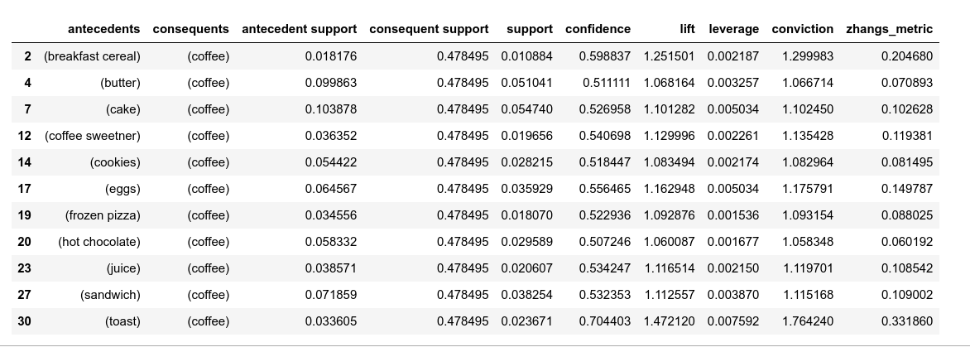

based on the table above, the interpretaion is therefore as follows

Rule 2: There is a strong association between the purchase of breakfast cereal and coffee. Approximately 1.1% of the transactions involve breakfast cereal, while 47.8% contain coffee. Furthermore, 1.1% of the transactions include both breakfast cereal and coffee. With a confidence of 59.9%, a significant portion of the transactions that contain breakfast cereal also involve coffee. The lift value of 1.25 suggests a 25% increase in the likelihood of purchasing coffee when breakfast cereal is present in the transaction. To optimize coffee sales, it is recommended to strategically position coffee near the breakfast cereal section.

Rule 4: There exists a connection between the purchase of butter and coffee. Around 10% of the transactions include butter, while 47.8% involve coffee. Additionally, 5.1% of the transactions contain both butter and coffee. With a confidence of 51.1%, more than half of the transactions containing butter also involve coffee. Although the association is not particularly strong, it may be worth monitoring customer preferences and exploring potential complementary pairings between these products.

Rule 7: Customers who buy cake are likely to purchase coffee as well. Roughly 10.4% of the transactions include cake, while 47.8% involve coffee. Among them, 5.5% of the transactions have both cake and coffee. With a confidence of 52.7%, more than half of the transactions containing cake also involve coffee. Leveraging this association can be done by promoting coffee alongside cake or offering coffee and cake bundles.

Rule 12: The purchase of coffee sweetener is linked to buying coffee. Approximately 3.6% of the transactions involve coffee sweetener, while 47.8% contain coffee. Among these, 2% of the transactions have both coffee sweetener and coffee. With a confidence of 54.1%, more than half of the transactions containing coffee sweetener also involve coffee. To make the most of this association, placing coffee sweeteners near the coffee section or offering promotions involving coffee sweeteners can be effective strategies.

Rule 14: There is a moderate association between cookies and coffee. Roughly 5.4% of the transactions include cookies, while 47.8% contain coffee. Moreover, 2.8% of the transactions have both cookies and coffee. With a confidence of 51.8%, over half of the transactions containing cookies also involve coffee. Capitalizing on this association can be achieved by offering coffee and cookies as a package or placing them together in displays to enhance the likelihood of customers purchasing both items.

Rule 17: Eggs and coffee show a weak association. Approximately 6.5% of the transactions involve eggs, while 47.8% contain coffee. Among these, 3.6% of the transactions have both eggs and coffee. With a confidence of 55.6%, more than half of the transactions containing eggs also involve coffee. Monitoring customer preferences and emphasizing the connection between eggs and coffee could lead to increased sales of both items.

Based on these findings, it is recommended to strategically position coffee near the breakfast cereal section, promote coffee alongside cake, explore complementary pairings, and leverage the associations between coffee and cookies, coffee sweeteners, and eggs. Monitoring customer preferences and experimenting with bundling or promotional strategies can maximize sales opportunities and enhance customer satisfaction within the context of the provided data.

meaning of the metrics in the table above

Support:

Support is a measure of the frequency or proportion of transactions containing a specific item or itemset. It indicates how often an item or itemset appears in the dataset. A higher support value signifies a more frequent occurrence of the item or itemset in the dataset. Support is calculated by dividing the number of transactions containing the itemset by the total number of transactions.

Confidence:

Confidence quantifies the conditional probability of finding the consequent item(s) in a transaction given the presence of the antecedent item(s). It measures the strength of the association between the antecedent and consequent. A higher confidence value indicates a stronger likelihood of the consequent being present when the antecedent is present. Confidence is calculated by dividing the support of the itemset containing both the antecedent and consequent by the support of the antecedent.

Lift:

Lift evaluates the strength of association between the antecedent and consequent items, taking into account their individual support values. It compares the observed likelihood of finding both the antecedent and consequent together to the expected likelihood if they were statistically independent. A lift value greater than 1 suggests a positive association, indicating that the presence of the antecedent increases the likelihood of the consequent being present. A higher lift value indicates a stronger association.

Leverage:

Leverage calculates the difference between the observed frequency of the antecedent and consequent occurring together and the expected frequency if they were statistically independent. It indicates whether the presence of the antecedent and consequent together occurs more or less frequently than expected by chance. A positive leverage value suggests a positive association, indicating that the presence of the antecedent and consequent together is more frequent than expected.

Conviction:

Conviction measures the degree of implication of the consequent based on the presence of the antecedent. It quantifies the impact of the association rule by assessing how much the confidence differs from 1. A conviction value greater than 1 indicates that the consequent is dependent on the antecedent, and the association is unlikely to occur by chance. A higher conviction value signifies a stronger implication.

Zhang's Metric:

Zhang's metric is an evaluation measure for association rules that combines support, confidence, and lift. It aims to capture the strength of association between the antecedent and consequent. A higher Zhang's metric value indicates a stronger association between the antecedent and consequent. It provides a comprehensive assessment of the rule's significance by considering multiple aspects of association.

These metrics aid in understanding and evaluating the associations discovered by the Apriori algorithm. They offer insights into the frequency, strength, and significance of the associations, enabling informed decision-making for marketing

Antecedents: Antecedents refer to the items or itemsets present on the left-hand side of the association rules. They signify the conditions or predictors in the rule, representing the items or combinations of items that are expected to be found in the transaction for the rule to be applicable.

Consequents: Consequents pertain to the items or itemsets located on the right-hand side of the association rules. They represent the items or combinations of items that are predicted or suggested by the rule when the antecedents are present in the transaction. These items are likely to be purchased or associated with the antecedents.

Antecedent Support: Antecedent support corresponds to the proportion of transactions in the dataset that contain the antecedent item or itemset. It indicates the frequency at which the antecedents occur in the transactions. Antecedent support is calculated by dividing the number of transactions containing the antecedent by the total number of transactions.

Consequent Support: Consequent support signifies the proportion of transactions in the dataset that contain the consequent item or itemset. It represents the frequency of occurrence of the consequents in the transactions. Consequent support is calculated by dividing the number of transactions containing the consequent by the total number of transactions.